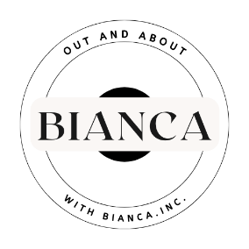
Out and About with BIANCA Inc.
A Registered Not For Profit Association
To order by mail, please email the *required information to:
outandaboutwithbianca@gmail.com
* NUMBER OF BOOKS REQUIRED: @ $55 per book. (Posted Free)
* TOTAL AMOUNT OF BANK TRANSFER: $
* YOUR NAME:
* POSTAL ADDRESS:
*CONTACT PHONE NUMBER:
Your book/s will be posted upon receipt of bank transfer.
Bendigo Bank Hervey Bay
Account Name: Out and About with Bianca Inc.
BSB: 633 000
Account: 228 468 732
* Please ensure your name is on the transfer to avoid confusion *

